Group Members
- Akshay Surve
- Amit Bhatta
- Shreyans Patil

K2 Cold Storage Case-Study – Problem 1
Refer to the K2_Cold_Storage_Temp_Data in the Appendix
- Cold storage temperature for Summer, Winter and Rainy Season are 3.15ºC, 2.7ºC and 3.04ºC respectively
- Mean cold storage temperature for the full year is μ = 2.9627 ºC
- Standard Deviation for the full year is σ = 0.5086 ºC
- Have drawn normal distribution plot for given datapoints. It shows the bell curve. To calculate probabilities, we calculate Z value using NORM.DIST function in excel
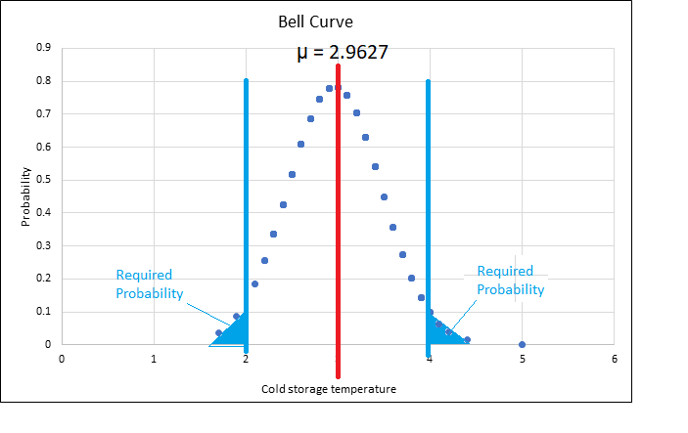
Z = (X – μ)/ σ
Probability of temperature having fallen below 2ºC is 2.92%
- Probability of temperature having gone above 4ºC is 2.07%
- From above, it is statistically proven that probability of temperature going outside the 2ºC - 4ºC during the one-year contract is above 2.5% and less than 5%. Hence, the penalty would be 10% of AMC amount.

K2 Cold Storage Case-Study – Problem 2
Refer K2_Cold_Storage_Mar2018 in Appendix
What we know is
Sample size (n) | 35
Population Mean (μ) | 2.96274
Population SD (σ) | 0.508589
Sample Mean (X) | 3.974286
Sample SD (S) | 0.159674
Critical value (α) | 0.1

Z test
Supervisor has been vigilant to maintain the temperature below 3.9 ºC.
The null hypothesis is

H₀ : The cold storage temperature is below 3.9 ºC i.e. μ <= 3.9 ºC

Alternative hypothesis

H₁: The cold storage temperature is above 3.9 ºC i.e. μ > 3.9 ºC

Selected sample size n =35 and level of significance α = 0.1
Population parameter value σ is known. We use normal distribution and calculate Z_{STAT} test statistic.

Critical values of Z_{STAT} the are -1.64 and +1.64. The rejection region is Z_{STAT} < -1.64 or Z_{STAT} > +1.64. The non-rejection region is -1.64 <= Z_{STAT} <= +1.64

Z_{STAT} = X – μ / (σ / $√n$) = 11.76664537
As Z_{STAT} 11.76664537 is > 1.64, we reject the null hypothesis. We conclude that there is evidence cold storage temperature has been more than 3.9 ºC and there is a need for some corrective action in the cold storage plant. It is not the problem from procurement side for consumers of the dairy products going sour and often smelling.

t test
Supervisor has been vigilant to maintain the temperature below 3.9 ºC.
The null hypothesis is
H₀ : The cold storage temperature is below 3.9 ºC i.e. μ <= 3.9 ºC

Alternative hypothesis
H₁: The cold storage temperature is above 3.9 ºC i.e. μ > 3.9 ºC

Selected sample size n =35 and level of significance α = 0.1
We assume that population of cold storage temperatures is approximately normally distributed and calculate t_{STAT} test statistic.

Degrees of freedom = 35 – 1 = 34
Critical values of t_{STAT} the are -1.6909 and +1.6909. The rejection region is t_{STAT} < -1.6909 or t_{STAT} > +1.6909. The non rejection region is -1.6909 <= t_{STAT} <= +1.6909

t_{STAT} = X – μ / (S / $√n$) = 37.4787714
As t_{STAT} 37.4787714 is > 1.6909, we reject the null hypothesis. We conclude that there is evidence cold storage temperature has been more than 3.9 ºC and there is a need for some corrective action in the cold storage plant. It is not the problem from procurement side for consumers of the dairy products going sour and often smelling.

Appendix

